**QSMART – LASER HEAD HARNESS AND COVER SWITCH REPLACEMENT PROCEDURE**

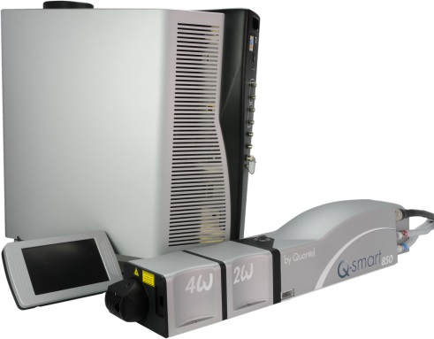

**Toolkit:**

Allen keys

**System**: QSMART

|  |  |  |  |  |  |  |  |  |
| --- | --- | --- | --- | --- | --- | --- | --- | --- |
|  | | | | |  |  |  |  |
| |  |  | | --- | --- | | 4/300/1071A | **Q-SMART LASER HEAD HARNESS** | |  |  | | 4/INT/0010 | **Q-SMART COVER SWITCH** | |  |  |  |
|  |

**Purpose**: This document details how to change laser head harness and the cover switch

|  |  |  |
| --- | --- | --- |
| Revision | date | modification |
| Initial issue | July 4, 2014 |  |
|  |  |  |
|  |  |  |
|  |  |  |

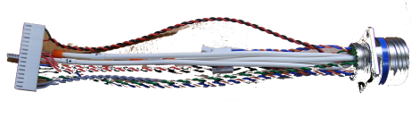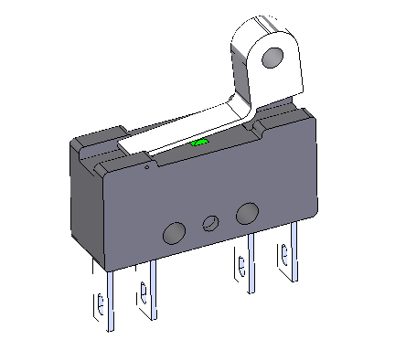

# DISASSEMBLING

* Turn the system off
* Disconnect cables and water hoses from the side of the laser head
* Remove the laser head cover.
* Remove the side plate (7 BHC 3x6)

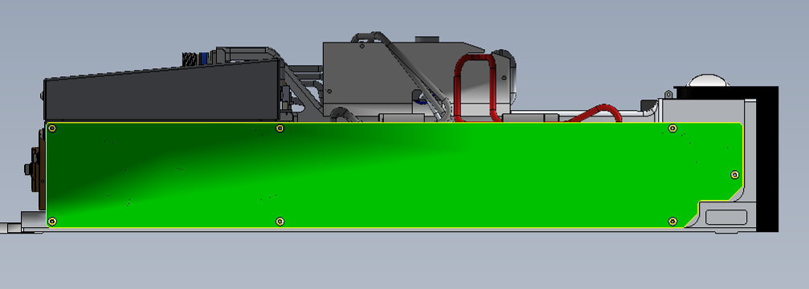

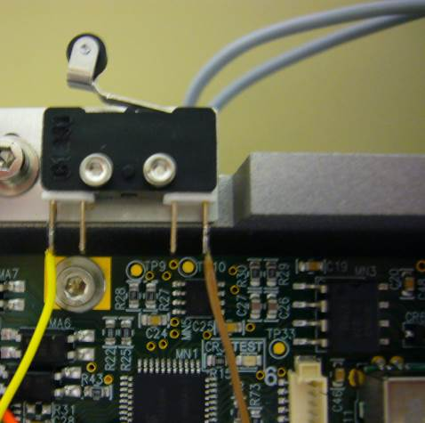

* Unsolder yellow and brown wires of the LED card on external contacts of the switch.
* Remove the 2 CHC2x10 to remove the switch 4/INT/0010

# IMPLEMENTATION OF THE SWITCH

|  |  |  |
| --- | --- | --- |
| 2.00 | V/CHC-M0210A4 | CHC2X10 SCREW |

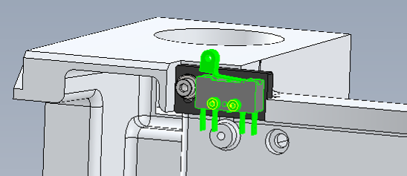

* Fasten the switch 4/INT/0010 with 2 CHC2x10 screws.



* Weld the yellow and brown wires of the LED card on their external contacts of the switch.
* See the procedure 4_300_1036 - Q-SMART LB CCA to connect the LB card

# DISASSEMBLING OF THE LASER HEAD HARNESS

* Turn the system off
* Disconnect cables and water hoses from the side of the laser head
* Remove the laser head cover.
* Remove the side plate (7 BHC 3x6)



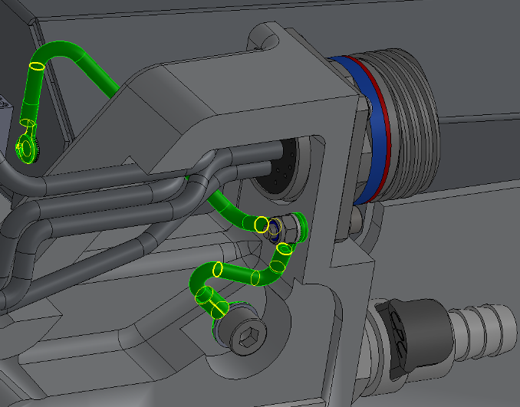

* Remove the two ground wires of the head harness

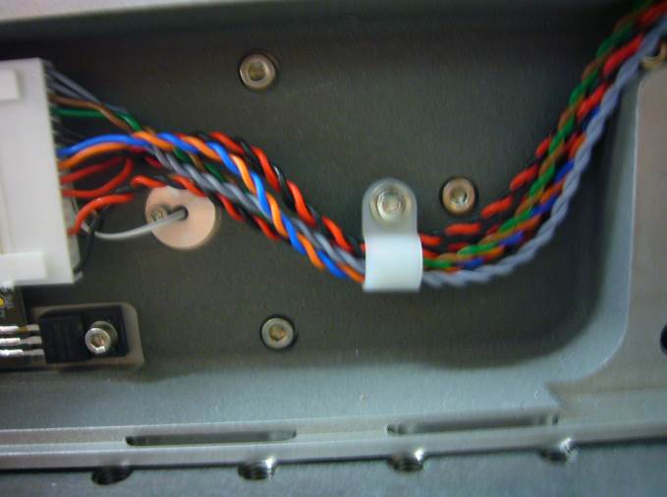

* Disconnect the 2-pin connector (J5) of the trigger card, the 16-pin connector (J4) of the LB card and the 6-pin connector (J3) of the Q Switch.
* Remove the cable fastener 4/CBL/0303
* 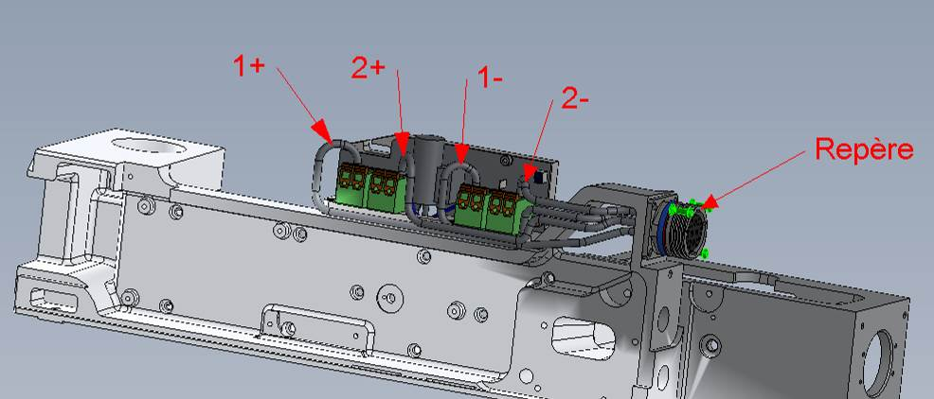 Remove the head harness connector 4/300/1071 (3 screws BHC3x8 + 3 washers ZU3 with). Disconnect the flashes wires as shown.

Connector

# IMPLEMENTATION OF THE LASER HEAD HARNESS

|  |  |  |
| --- | --- | --- |
| 1.00 | 4/300/1071 | LASER HEAD HARNESS |
| 1.00 | 4/CBL/0303 | CABLE FASTENER NX3 |
| 1.00 | V/BHC-M0306A4 | BHC 3X6 SCREW |
| 3.00 | V/BHC-M0308A4 | BHC3X8 SCREW |
| 1.00 | V/CHC-M0308A4 | CHC3X8 SCREW |
| 1.00 | V/CHC-M0318A4 | CHC3X18 SCREW |
| 1.00 | V/CHC-M0510A4 | CHC5X10 SCREW |
| 1.00 | E-NYLSM03-- | NYLSTOP M3 NUT |
| 6.00 | R-ZU--D03--A2 | ZU3 WHASHER |
| 1.00 | R-ZU--D05--A2 | ZU5 WHASHER |
| 1.00 | R-DEC-D03-- | LOCK 3 WHASHER |

Connector

*  Fasten the head harness connector 4/300/1071 (3 screws BHC3x8 + 3 washers ZU3 ) the “A” mark behind the connector should be on top. Connect the flashes wires as shown.
* Connect the 2-pin connector (J5) of the trigger card, the 16-pin connector (J4) of the LB card and the 6-pin connector (J3) of the Q Swith. Fasten the cables in the cable fastener 4/CBL/0303 and attach it to the foundry (CHC 3x8 screw + ZU3 washer).
* Attach the two ground wires of the head harness to the connector (CHC screws 3x18 + 2 ZU3 washers +1 Nylstop M3 nut).
* Fasten to the foundry (CHC 5X10 + ZU5).
* Screw the Q Switch ground wire to its cover(BHC 3x6 screw + Lock washer DEC3 )
* Close the Laser head and put warranty stickers   
  *Refer to "LH-Warranty Labels"*